Comments on the OECD Public Discussion Draft on the BEPS Action 7:
Preventing the Artificial Avoidance of Permanent Establishment Status
Paris, 9 January 2015

1. The TUAC welcomes the opportunity to provide comments on various OECD amendment proposals to article 5 of the OECD Model Tax Convention to fulfil the commitment by the G20 to prevent the artificial avoidance by multinational enterprises (MNEs) of the permanent establishment (PE) status for the legal setting of their foreign activities, as outlined under Action n°7 of the Base Erosion and Profit Shifting (BEPS) Action Plan. Action 7 specifies the OECD and G20 commitment to “develop changes to the definition of PE to prevent the artificial avoidance of PE status in relation to BEPS, including through the use of commissionnaire arrangements and the specific activity exemptions”.

Why it matters for workers
2. Trade unions are especially concerned that international tax rules should be reformed to ensure that multinationals are taxed “where economic activities take place and value is created”, as mandated by the G20 Leaders. Corporate BEPS tax avoidance practices by MNEs matter for governments and their tax collectors. They also matter for other corporate stakeholders. When an MNE escapes its obligations vis-à-vis the tax collector, its obligations vis-à-vis other stakeholders, including workers, may also be at risk. Trade union experience suggests that tax liability issues are intertwined with employer responsibility issues. There are two reasons for this, which are interrelated:

- Firstly, a central technique used by MNEs for evading their tax obligations is to elaborate formal corporate structures in which the allocation of functions to the various entities of the MNE is fragmented in a way that does not reflect the distribution of economic risks and added-value within the MNE group. These corporate restructurings aim at tax planning and tax arbitrage – but are not limited to this. They can also be used to evade other regulatory requirements, including in the areas of employment protection legislation, of collective bargaining and of worker representation. For trade unions, corporate tax avoidance planning is one form of a broader problem of corporate “regulatory planning” with short-termist goals.

- Secondly, corporate tax avoidance generally entails changing the entity to which profits are formally attributed, from a high to a low-tax jurisdiction. In practice, such profit shifting is likely to entail a profit shift from employment-rich or employment-generating entities to entities with either zero or irrelevant levels of employment.

Fragmentation and artificial avoidance of the PE status
3. The artificial avoidance of the PE status is part of a bigger problem of fragmentation of corporate functions. Dealing with the problem of fragmentation would require governments and tax administrations to adopt a less formalist approach to the design and interpretation of tax treaties. So far, the prevailing view in such treaties is that different entities are assumed to be “independent” from each other as long as there is a formal contract establishing this. This view will prevail even if the very same entities are de facto dependent from each other and are under common control by the same management and even if there is clear evidence that their employees are operating under a single economic employer.

4. When an MNE’s local businesses are fragmented into several separate entities and, accordingly, PE rules are not respected – either because the use of a PE status only covers part of the MNE’s local operations or because there is no PE status in the first place – the rights and well-being of local workers that are economically dependent on the MNE are likely to be at risk or less protected. Three aspects are to be taken on board:

- Employee remuneration, as a result of an artificial fall in local profits that would not reflect the level of risk to which workers are exposed (case of absence of a PE, or partial coverage of it, case of fragmentation);
- Coverage and quality of the collective bargaining agreement (case of fragmentation); and
- Worker information and consultation rights (fragmentation).

5. The annex to this paper provides a concrete example of fragmentation of an MNE subsidiary. Local profits fell sharply after a restructuring process without corresponding changes in the functional responsibilities or exposure to risk of the subsidiary’s activities. According to trade unions of the subsidiary entities and their advisers, the fall in profit was due to a combination of factors:
- Manipulation of transfer pricing;
- Shift of status of the local entities from primary contractor to subcontractor and from fully fledged to limited risk distributor (LRD);
- Fragmentation of the local activities in several separate entities;

6. While the case primarily relates to manipulation of intra-group transfer pricing, it has some bearing on the PE discussion and the consequences of fragmentation of activities and of an undue shift to LRD status.

Comments on the proposed amendments to article 5
7. TUAC welcomes the proposals put forward by the OECD to strengthen existing #5 of article 5 on the requirement for PE for persons “acting on behalf” of an MNE company, by focusing on the substance of the contract (“what is the object of the contract”) rather than its form (“who is bound by the contract”) as is currently the case (those who have “authority to conclude contracts”) and to limit the exemption for sales agents paid on commission under #6 – by strengthening the criteria for independence (vis-à-vis the MNE) to benefit from the exemption.

8. Looking at the four proposed alternative amendments (A, B, C & D), our preference goes to options A and C which require PE status for intermediaries that regularly “engage with specific persons in a way that result in the conclusion of contract”. As such, both A & C focus on the substance of a contract rather than its form and are comprehensive enough to cover the various contractual processes between a sales staff or entity and their clients that MNEs can set in place to avoid the PE regime.

9. We also welcome the proposals of amendments to #4 to restrict the specific activity-related exemptions. We support proposals that make explicit that any exempted activity should be of preparatory or auxiliary nature (option E). We support the proposal to add an anti-fragmentation clause under a new #4.1 whereby complementary business activities would qualify as a PE regime – if there is evidence that, on aggregate, those activities would go beyond auxiliary or preparatory functions (option J).

10. More fundamentally however, the question remains as to whether the proposed OECD amendments are robust enough to ensure:
- A full coverage of the PE status to entities that are controlled or dependent on the MNE beyond those involved in sales and logistics and including marketing, manufacturing and back office, other services;
- A correct application of the PE status that truly reflects the economic distribution of risk between the MNE and its local entities and that, among others, would prevent abusive use of the LRD status.

11. We also note and welcome the separate contribution by the BEPS Monitoring Group (BMG) to this OECD public consultation.

Annex: A case study, the restructuring of CP France
Up until 2005, “CP Global” operated a decentralised organisation outside its parent jurisdiction in the US. The French subsidiary, CP France, was structured around a holding company which controlled all operational activities, including two production sites and several local commercial companies. From a tax point of view, the holding company was the Principal and “primary contractor” and hence reported all profits and net incomes generated in France.

The restructuring
In 2005 the European operations went through important structural changes. A new company was created in Switzerland, CP Beta, and became the primary contractor for all operations in Europe. As a result of this centralisation of businesses in Europe, the status of local distribution companies of CP France went from that of fully fledged distributor to limited risk distributor (LRD). The LRDs were buying CP finished products and selling them to French customers at pricing and terms of reference set by CP Beta which were equivalent to a 2.5% margin on the turnover made in France. LRDs nevertheless continued to hold important marketing and sales functions including: business development, contract negotiation; sales order and taking and execution of the marketing strategy set by CP Beta. Similarly the industrial sites became sub-contracted manufacturers with specific terms of reference and pricing arrangements that were also set unilaterally by CP Beta. The French holding company, which previously had a primary contractor role, became a service provider for the other French entities or for CP Beta, the pricing of which was set by CP Beta at cost+6%.

The business restructuring of CP France in 2005
Before: | After:
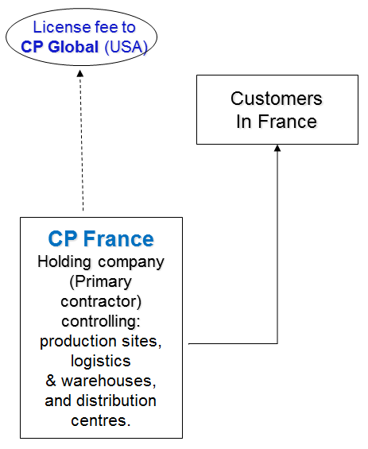 | 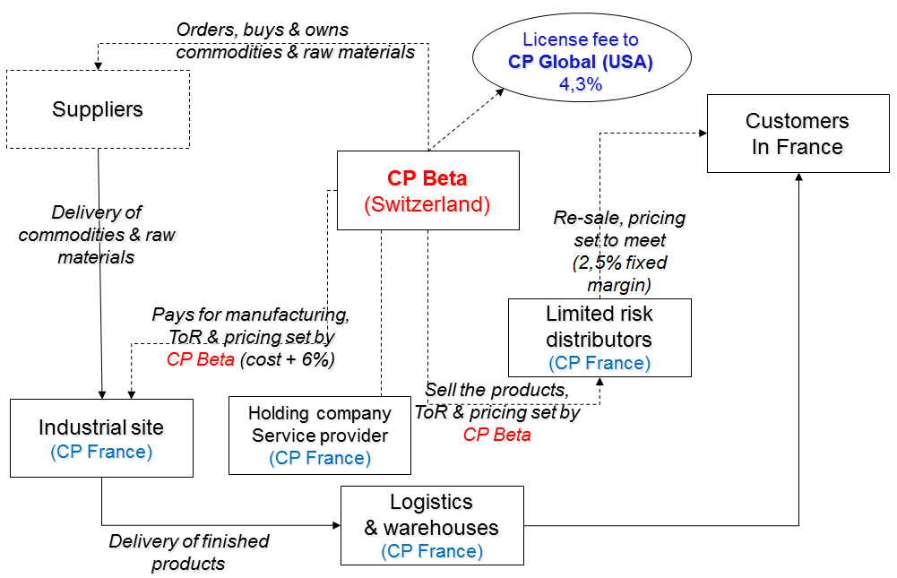

As a result of the restructuring, profits reported by the business entities in France fell sharply. The operating margin of the French commercial companies was divided by 4, from 10% to 2.5%. Suspecting illicit transfer pricing and transfer of profits abroad, the French tax administration launched a tax audit of the French subsidiary over the period 2005-2008. The French administration challenged the status of CP Beta as the primary contractor for French operations on the ground that:
- The reorganisation around CP Beta as the principal contractor did not lead to a growth of the turnover and of profits generated in France;
- CP Beta did not have the means to fulfil its responsibilities as shown by the fact that essential functions were subcontracted to the French holding company and other entities;
- CP Beta was under-capitalised to cope with the operational and market risks to which it claimed to be exposed to as a primary contractor in France; and
- It did not own the trademarks of the global brands.

Several millions of euros were claimed by the French tax administration in tax arrears. CP Global contested the decision by defending the primary contractor status of the Swiss entity and arguing that the fall in the margin rate of the French subsidiary was simply due to the transfer of risks to the Swiss entity. It further argued that the Swiss entity held the licensing rights for the use of the global brands in Europe, and that CP Beta controlled and was exposed to operational and market risks in France regardless of the fact that essential functions were indeed subcontracted to French entities.

Impact on workers employed by CP France
The restructuring of 2005, including (i) the fragmentation of CP France and (ii) the transfer of the primary contractor function to Switzerland had profound implications for the workers employee by CP France in three areas:
- The remuneration of workers, via the profit-sharing scheme of the company;
- The quality of the collective bargaining agreement; and
- The right of workers (established by French and EU law) to information and to consultation.

The restructuring of 2005 had a clear impact on the employee profit-sharing scheme of the French subsidiary. Profit-sharing schemes are common in France and may represent a non-trivial part of workers’ income, particularly for large companies and for subsidiaries of foreign MNEs. The schemes are regulated by law, including with regard to the formula for setting the share of profits to be reallocated to workers. The formula is entirely dependent on the level of equity or capitalisation of the company: the higher the level of equity, the lower the share of profits being distributed to the employees. The restructuring plan resulted in excessive levels of capitalisation of the French subsidiaries considering their supposedly reduced exposure to market and operational risks. Combined with an overall decrease in profit levels, the share of profits redistributed to workers fell sharply after the restructuring. It is estimated that the net gains for the MNE were over €1m per year more for 2006-2012 than in 2000-2005.

Workers’ rights to information and to representation were also negatively impacted. As a result of the fragmentation and restructuring in 2005, the status of the French entities shifted from limited liability company (société anonyme, S.A.) to “simplified” limited liability company (société anonyme simplifiée, S.A.S.). The SAS status was introduced in French corporate law to meet the specific needs of small companies, not those of mid-size companies. Compared with the SA regime, the SAS status offers much lower levels of worker rights to representation and information. The fragmentation of the French subsidiary into a plurality of small entities led to a considerable loss of information and of rights to consultation for workers of CP France, and thereby to a net loss of bargaining power of their representative institutions (works councils and trade unions).

It also led to a downgrading of the quality of the collective bargaining agreement covering the workers. In France, all workers (whether they are unionised or not) are covered by a collective agreement of the sector of activities under which the employer is registered. As a result of the shift from SA to SAS status and from primary contractor to sub-contractor roles, the French entities were registered under a different sector of activity covered by a collective agreement that had lower provisions and lower benefits than the one that prevailed prior to the restructuring.

Overall, the quality of social dialogue deteriorated fast following the restructuring, to the point where it can now be considered as close to non-existent. According to trade union representatives, the company’s human resource policy has shifted to a situation of “permanent redundancy planning”. A works council representative summed up the situation: “the farther you are from where tax is being declared within the MNE group structure, the higher the risk for worker misery”. The unions have attempted to bring attention to the aggressive tax planning scheme of CP Global before the French parliament – including calling for an official inquiry.
In 2012 CP Global generated USD17bn in net sales and USD2.5bn in net income. That year, CP Global spent USD3.2bn in dividends and share buybacks, USD865m in investing activities and USD1.3bn in payment of income taxes. From 2006 to 2009, net income / net sales ratio grew from 11.1% to 14.9% globally and has remained stable at 14.5% since then. The number of workers employed by CP globally has grown by a mere 3% between 2003 and 2012.

CP Global also submitted a comparability analysis which showed that its transfer pricing policy between the French and Swiss entities was indeed within the range of its competitors. It was however located in the lowest quartile of remuneration – while the exposure of the French entities to risk was located in higher quartiles. The French subsidiaries were remunerated at the lowest levels compared to its exposure to operational risk in France.

